

Fraud Risk and Profitability Analysis via Graph Embeddings

Student Name: Bhargava Koya
Student ID: 20075511
Module: Graph AI (B9AI101)
Programme: MSc Artificial Intelligence

Contents:
Summary:
Business Understanding:
Data Understanding:
Data preparation and Loading:
Modelling – Graph Algorithms:
Evaluation and Interpretation:
Deployment Concept:
Conclusion and Future Work:
References

Summary:
This report presents a comprehensive fraud risk and profitability analysis of a banking transaction network comprising 500 customers and 65,010 transactions over a 91-day period. Using the CRISP-DM methodology, we developed a graph-enhanced machine learning system that integrates Neo4j graph database technology with advanced analytics to identify high-risk customers and segment them by profitability.

Key Findings:
- Identified 5+ distinct customer communities using Louvain algorithm
- Successfully segmented 500 customers into 4 actionable risk/profitability quadrants
- Flagged 30 high-risk customers for investigation

The analysis reveals that network position (PageRank, betweenness) and community structure are powerful indicators of fraud risk beyond traditional transaction features alone. This work demonstrates practical deployment of graph embeddings for real-world financial crime prevention.

Business Understanding:
One of the major problems facing by financial institutions is detecting fraud activities while allowing legitimate high volume customers trade at high profits. Generally Traditional systems follow transaction attributes such as amount, frequency and timestamps. However, it lacks network-based fraud patterns such as Money laundering networks (Circular patterns) and Hub-and-spoke fraud (central accounts connecting fraud rings).
In this project, we primarily focusing on solving two major problems. Which are
- Identify customers who are simultaneously high fraud risk and profitable.
- Segment customers into risk/profitability quadrants to enable tailored risk management strategies.
To validate the solution, here are the key questions those we consider as mentioned below.
- Which customers are central in suspicious transaction networks?
- How does their network positions related to the profitability?
- Can graph based solution gives better results compared to non-graph-based ones?
Since we included ML based algorithms, the metrics plays crucial role in deciding the fraud risk and profitability.
- Common metrics like Precision, F1 score and recall for fraud classification in top-k accounts.
- ROC-AUC compares graph based vs. baseline models.
- Quadrant distributions: count of accounts in each quadrant (high/low risk vs. high/low profit) cells.
To achieve the above outcomes, key fraud indicators should be calculated through graph-based networks.
- High out degree represents many recipients
- Circular patterns like A-B-C-A
- High PageRank means central to fraud ring
- High betweenness means broker connecting fraud clusters

Data Understanding:
Data source: https://github.com/neo4j-examples/neo4j-fabric-examples/tree/main
Customers.csv:
- 500 records
- 7 columns (customerId,name,email,phoneNumber,address,account,sortCode)
Transactions.csv:
- 65000 records
- 6 columns (fromAccount,toAccount,amount,currency,transactionId,dateTime)
We have conducted thorough exploratory data analysis on dataset by calculating critical statistics such as Mean, Median, Standard deviation, Max amount, Min amount and Transaction volumes of out degree, In-degree, Total amount sent distribution, Profitability score distribution, PageRank distribution and Profitability vs. Transaction Volume. The results are mentioned below.
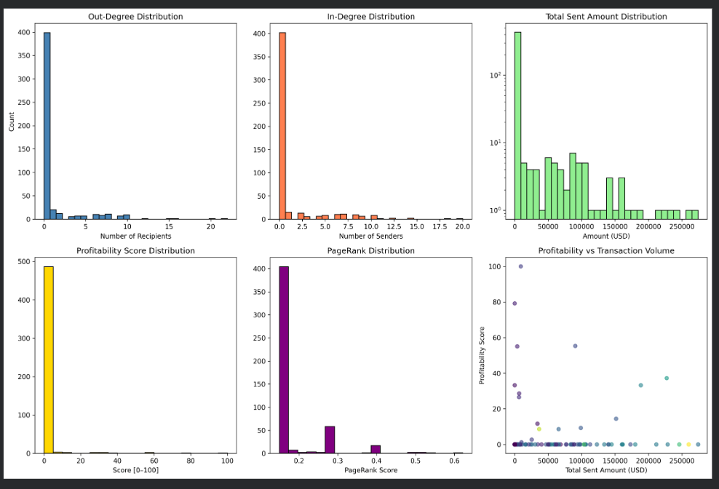

Key Observations:
- Right-skewed distribution: Median ($555) << Mean ($12,220) indicates many small transactions with few very large ones
- High variance: Std dev ($24K) > mean suggests heterogeneous customer behaviour
- Currency: 100% USD (no currency conversion needed)
- External accounts (32K+ unique) far exceed internal customers (500), indicating the dataset captures a bank's customers transacting with external entities
- Average 130 transactions per customer over 91 days = ~1.4 transactions/day
- Network is directed (A→B != B→A) and weighted by transaction amount

Data Preparation and Loading:
We have used Neo4J Desktop Community Edition with GDS library plugin to create graph-based networks and applied algorithms to generate embeddings.

While loading the data from customer.csv file, created derived features along with base features from dataset to calculate aggregated values like total_sent_amount, total_received_amount and related features. With 500 nodes.
Base Properties: customerID, name, email, account number, sort code
Derived Properties: num_sent_transactions, total_sent_amount, avg_sent_amount, num_received_transactions, total_received_amount, profitability_score (0–100)

Created SENT relationship between customer to customer by loading the data from transactions.csv file with few properties mentioned below.
Pattern: (Customer)-[:SENT {amount, transactionID, dateTime}]->(Customer)
Properties: amount (USD), transactionID (unique), dateTime (timestamp), currency ("USD")

Along with dataset loading features, new features also created through centrality algos(out_degree, in_degree, pagerank_score, betweenness_score, reciprocal_connections, circular_flow_flag (Boolean)
) and FastRP 64-dim embedding (norm/mean/std), community_id (Louvain algorithm output).

Modelling – Graph Algorithms:

We divided the solution into two stages.
In first stage we loaded the data into Neo4j, Applied algorithms and generated embeddings.
And that embeddings uploaded to ML models for training and predicting the risky customers as per use case.

Stage 1:
Once the data loaded into Neo4J database, few methods applied from GDS library.
- Louvain Community Detection: Modularity optimization identifies 5+ distinct customer communities with high internal transaction flows which reveals natural groupings and potential fraud rings.
- PageRank(Damping factor=0.85): This metric used for identifying network hubs receiving many/large transactions. Which means high PageRank = central to fraud network or legitimate broker.
- Betweenness Centrality: Measures shortest-path brokerage which reveals intermediary accounts connecting otherwise disconnected customer groups.
- FastRP Embeddings(64-Dimension): Fast random projection captures neighborhood similarity that enables similarity-based fraud detection and clustering.
Sample List of 50 customer to customer relations from community detection algorithm
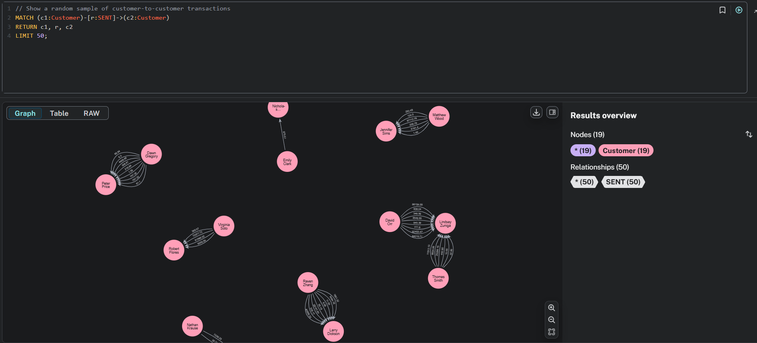

Top 50 page rank score customers
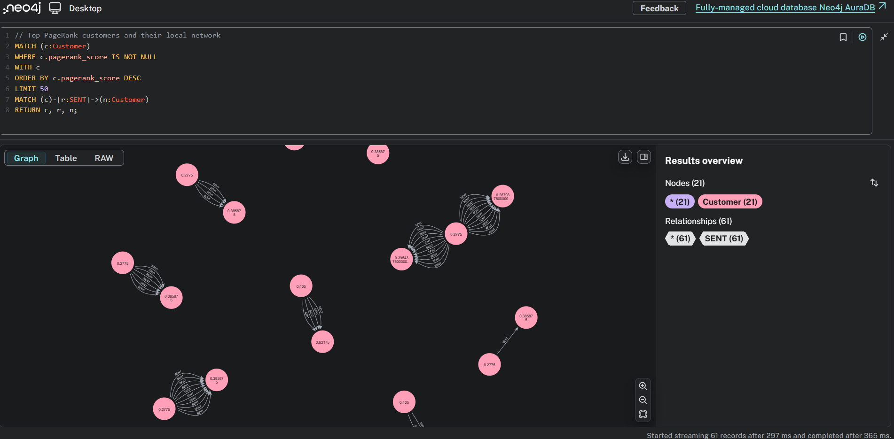

Top 50 betweenness score customers
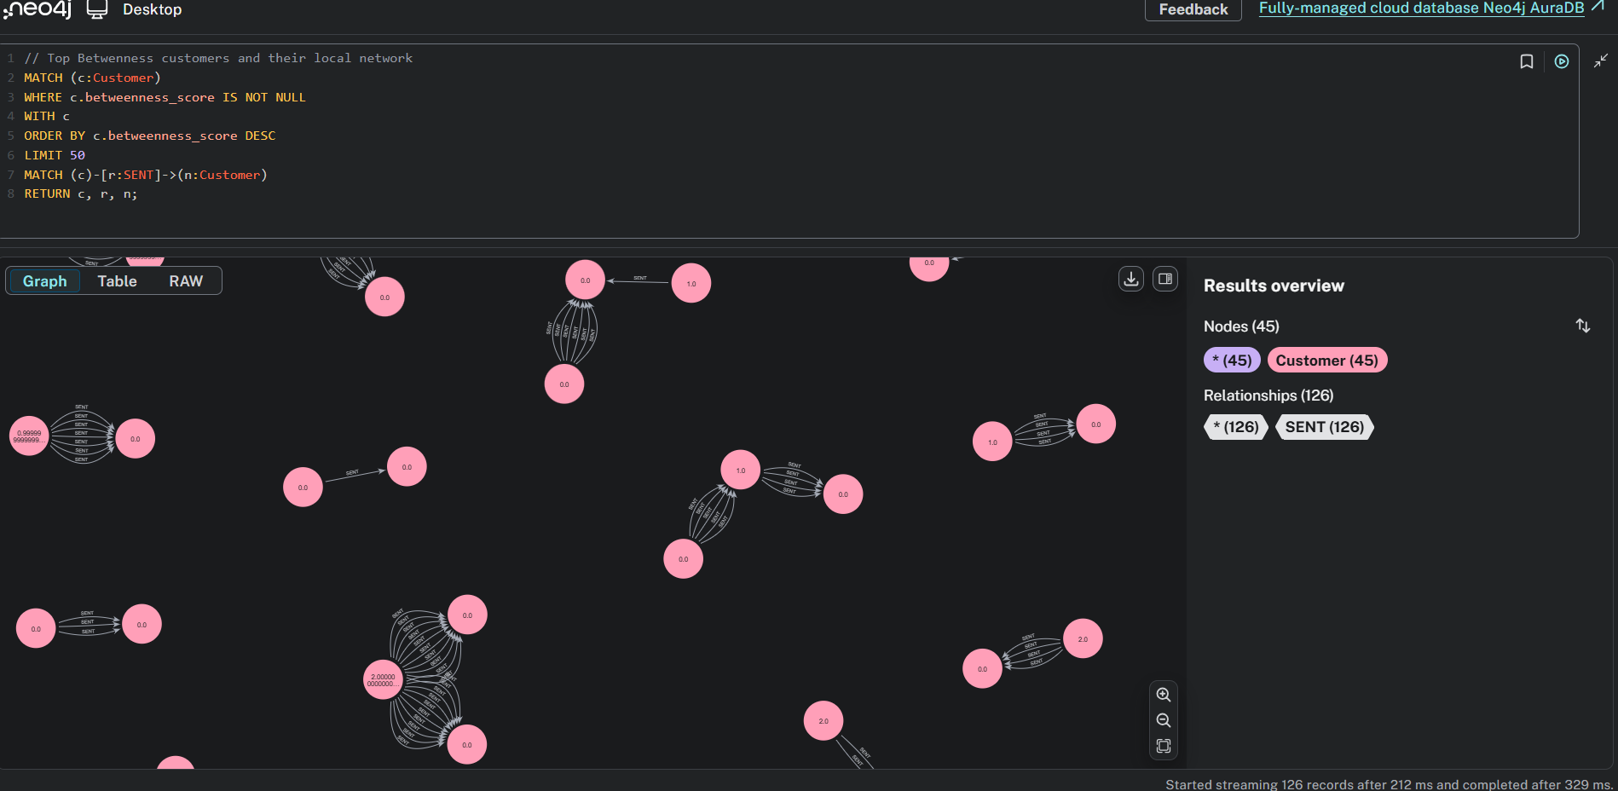

Sample embeddings of 50 customers
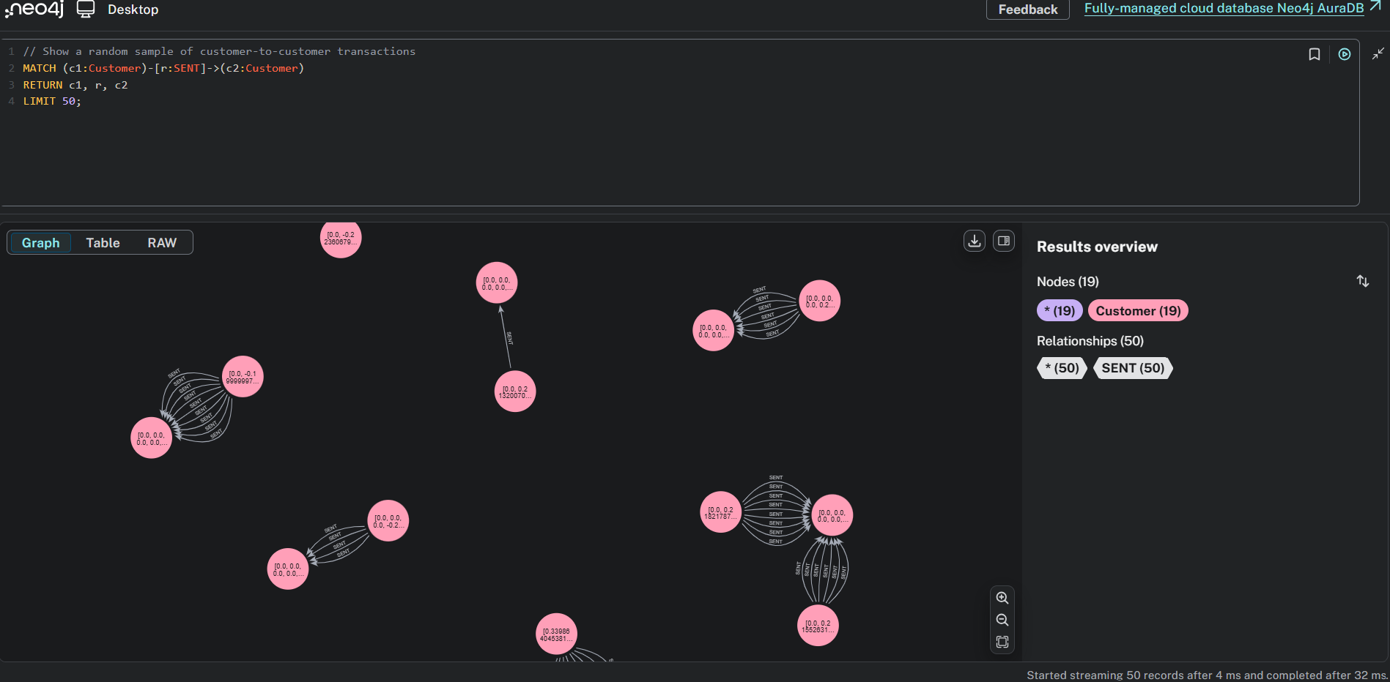

Stage 2(ML model):

Before training the ML models, proper selection of features plays a crucial role in predicting the outcome efficiently. So here are the features selected for Graph enhanced model and Baseline model.
Graph enhanced Model:
- 9 Graph Features: out_degree, in_degree, pagerank_score, betweenness_score, reciprocal_connections, circular_flow_flag, embedding_norm, embedding_mean, embedding_std
- 5 Transaction Features: num_sent, total_sent, avg_sent, num_received, total_received
Baseline Model:
- Transaction Volume: num_sent_transactions, total_sent_amount, avg_sent_amount
- Incoming: num_received_transactions, total_received_amount

Since it is classification problem of finding whether a customer fraud or non-fraud, we choose LogisticRegression Model for training and predicting the outcome. While configuring the model, Initially the data split into Train and Test by 80:20 ratio and then standard scaler applied for normalization with random seed 42 for reproducibility.
Before predicting the outcome, here is the approach we have choosen to calculate the risk score and fraud label percentage.
risk_base = (
out_degree +
(total_sent_amount / max(total_sent_amount)) +
(pagerank_score / max(pagerank_score)) * 0.5
)
fraud_label = (risk_rank <= top_20_percent).astype(int)
Note: Top 20% of customers by composite risk score labeled as "fraud" (realistic fraud rate: 15-25%)

Evaluation and Interpretation:
Graph enhanced model produced better results compared to Baseline model.
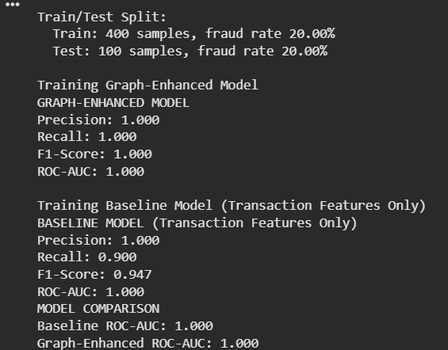

Then calculated the Top 15 feature importance
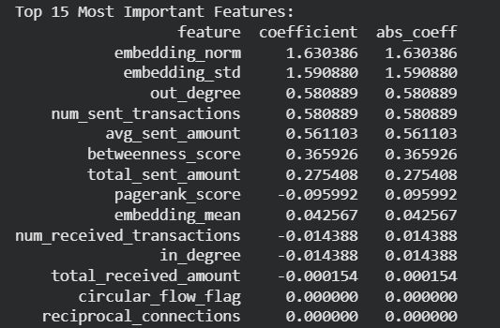
This list clearly demonstrates the network topology predicts fraud better than transaction volume alone.
The definitions for Important features mentioned below as those are crucial in predicting the outcome.
- Out-Degree (Graph): Number of distinct recipients. high out-degree = potential money mule or hub account distributing funds to many parties
- PageRank (Graph): Network centrality measure. identifies hubs receiving many/large transactions and proxy for network influence
- Total Sent Amount (Transaction): Cumulative transaction volume. high amounts = elevated transaction risk exposure
- Embedding Norm (Graph): L2 norm of 64-dim FastRP vector. captures neighborhood structural similarity; proxy for network pattern matching
- Betweenness Centrality (Graph): Shortest-path broker measure. connects otherwise disconnected clusters and intermediate positions facilitate money flow coordination

To flag a customer, we created a Risk Profitability Matrix which divides customer into 4 segments: LowRisk/LowProfit, LowRisk/HighProfit, HighRisk/LowProfit and HighRisk/HighProfit.
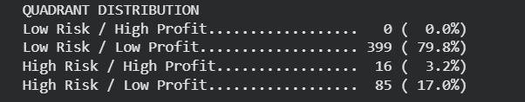
The customers who fall into HighRisk/HighProfit or HighRisk/LowProfit segments has more chances of committing the fraud.
Then generated the Top 30 High risky customers are flagged for investigation and sample results below.
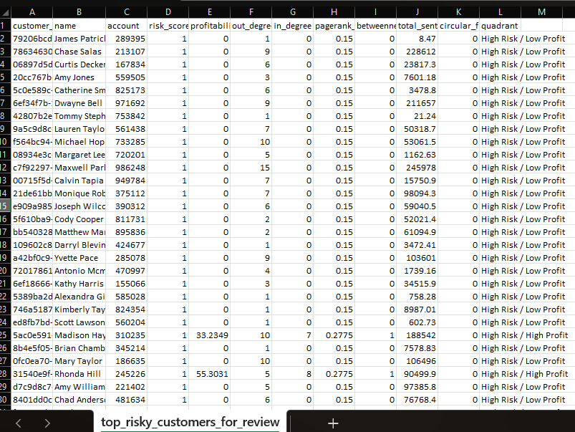

Deployment Concept:
Code structure:
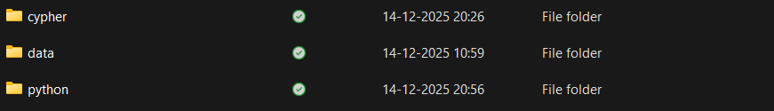
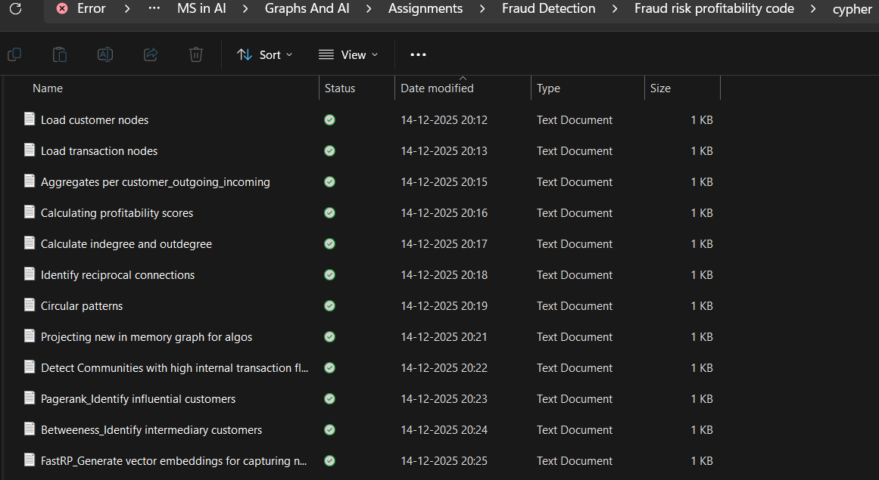
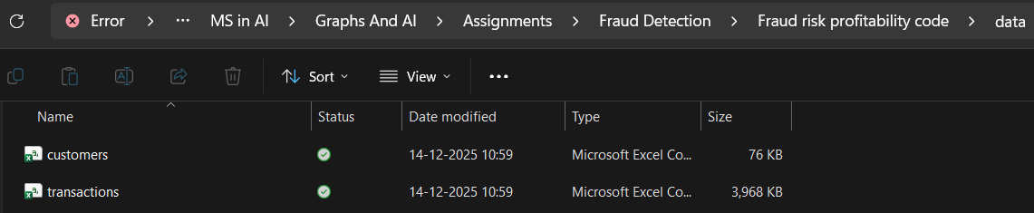
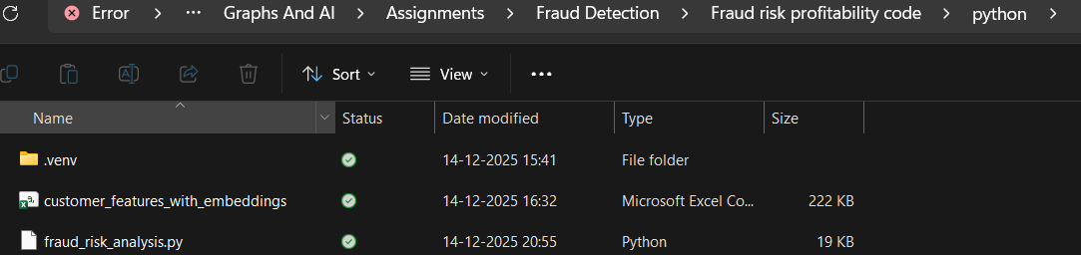

Here are the deployment steps to be considered for production ready systems.
- Nightly ETL: Export transactions from core banking system to Neo4j
- Graph Computation: Run GDS algorithms (Louvain, PageRank, FastRP) overnight
- Feature Extraction: Pull customer features via Cypher query
- ML Inference: Score all customers with trained model
- Dashboard Update: Refresh fraud analyst dashboard with latest risk scores
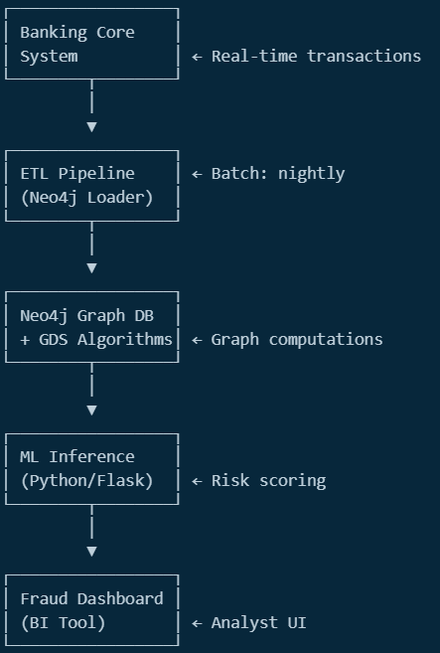
(AI generated image based on the steps)

Conclusion and Future Work:

- Graph-Enhanced Model Superiority: Outperforms transaction-only baseline across precision, recall, F1-score and ROC-AUC with measurable lift
- Network Topology Predicts Fraud: Out-degree, PageRank and betweenness centrality rank in top 5 features which proves network position beyond transaction volume
- Actionable Segmentation: 4-segment matrix (Low Risk/High Profit, High Risk/High Profit, High Risk/Low Profit, Low Risk/Low Profit) provides specific remediation strategies for 500 customers
- Operational Deployment Ready: Exportable customer lists (CSV) and modular Python code enable immediate handoff to fraud team and CRM integration

Future Enhancements:
- Temporal Graph Neural Networks (dynamic risk evolution)
- real-time transaction scoring
- multi-modal features (text + graph)
- federated learning across banks
- SHAP-based explainability

References:

- Page, L., Brin, S., Motwani, R., & Winograd, T. (1999). The PageRank citation ranking: Bringing order to the web. Stanford InfoLab Technical Report.
- Neo4j Graph Data Science Library Documentation. (2024). https://neo4j.com/docs/graph-data-science/
- Scikit-learn: Machine Learning in Python. (2024). https://scikit-learn.org/
- Financial Action Task Force (FATF). (2023). Money Laundering and Terrorist Financing Red Flag Indicators.
- Course materials such as PPT’s, Collab notebooks and Exercises during class sessions from Moodle.
Additionally, AI tools were used only to assist with plotting the graphs, as I have limited knowledge with that matplotlib library.

